GREX - Agenda point 3.3. Anomalous Parameters

EVIDENCES OF OILS FORM ITALY HAVING ANOMALOUS PARAMETERS

- ANOMALIES AFFECTING EXTRA VIRIGIN OLIVE OILS

Representatives of the olive producers and bottler associations have reported to the Italian Ministry of Agricultural, Food and Forestry Policies (MIPAAF) specific issues concerning extra virgin olive oil of specific varieties with a natural content of total sterols less than 1000 mg/kg, and therefore not compliant with current EU legislation.
This anomaly occurred on a cyclical basis for several olive years and is affecting in particular high-quality oils, otherwise certifiable as PDO or PGI.
In critical years, like crop year 18/19, the rate of non-compliant oil was estimated greater than 20% of the entire production of concerned areas. Early harvest is identified as one factor that increases the rate on non-compliancy.
A specific study campaign on samples of known origin was organized by the Italian Ministry of Agricultural, Food and Forestry Policies in 2019. The study was financed by FOOI (Filiera Olivicola Olearia Italiana).
Samples analysis was carried out by the Anti Fraud Department ICQRF, of the MIPAAF.

EXTRA VIRGIN ANALYSIS RESULTS

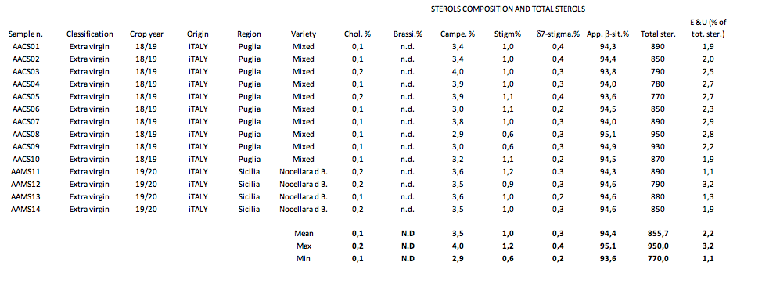

- ANOMALIES AFFECTING OTHER OLIVE OILS

Associations of Italian producers have for many years reported authentic lampante oils of known origin from the southern regions of Italy, Puglia and Calabria, whose values of apparent β-sitosterol are lower than the limit of 93% set in the annex I of Regulation (EEC) No 2568/91 .
The β-sitosterol is a parameter of paramount importance for assessing the genuinity of lampante oils according to the regulation.
A specific study ​ carried out by the ICQRF Department found very low β-sitosterol values on several batches of lampante olive oil.
In some cases, these lampante olive oils represented a significant part of local production.
It is clear that these anomalies cause damage to the sector not only because of the impossibility of processing these products (refineries do not accept such oils for processing), but also because legal problems may occur only for the simple detention of such products.
Indeed, oils displaying this anomaly, when officially sampled are considered as adulterated.

LAMPANTE OILS RESULTS
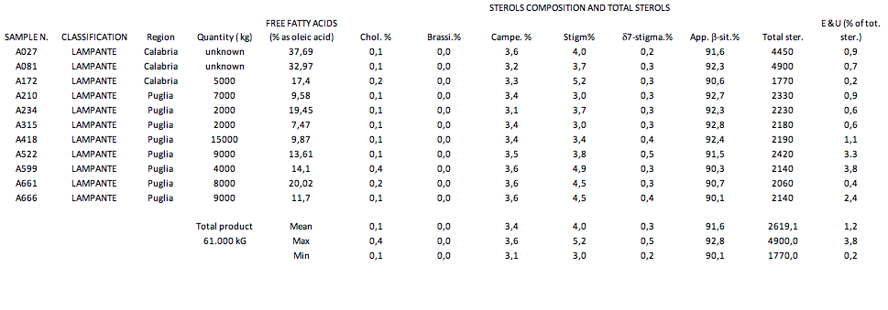

CONSIDERATIONS

EXTRA VIRGIN OLIVE OILS
The low sterol content anomaly is affecting a significant part of the Italian extra virgin olive oils and needs to be addressed with a solution.
The total sterol content is a parameter used to prevent undetected addition of seed oil to olive oils which have undergone sterol removal.
In the case of virgin end extra virgin olive oils, the diagnostic value of this parameter is quite limited as stigmastadienes are a more sensitive marker for revealing the presence of oils than have been refined (desterolization generally leads to stigmastadienes formation).
Italy is in favor of studying a decision tree, which for example, could take into account the coherence of triglycerides’ composition according to the COI/T.20/Doc.method.Nº 25 - Evaluation of the coherence of TAG composition and fatty acid composition, or other technically feasible solutions.

LAMPANTE OLIVE OILS
The β-sitosterol is a very important and sensitive parameter for the verification of the authenticity of olive oils. Therefore, the development of a decision tree for olive oils presenting this issue will have to respond to the need to always ensure the genuinity of the bulk of olive oils traded worldwide.
Italy is in favor of exploring the possibility to develop specific local solutions in order to allow a limited circulation of these products from the producer sites to refining plants.

